

**CLIENT**

Dynamics 365:

Disaster recovery & High availability

March 4, 2024

**Table of Contents**

Dynamics 365 F&O Production MSFT Disaster recovery & High Availability 1

Business Continuity and Disaster Recovery 1

High Availability 1

Geo-replication 1

Tier-2 sandbox recovery 1

High Availability 1

Geo-replication 1

Tier-1 disaster recovery/availability 1

Dynamics 365 Project Operations/CE 1

Business Continuity and Disaster Recovery 1

Sandbox Environments 1

Azure DevOps 1

High Availability 1

Geo-replication 1

Power BI 1

Power BI High Availability 1

# Dynamics 365 F&O Production MSFT Disaster recovery & High Availability

## Business Continuity and Disaster Recovery

Resource: [Business continuity and disaster recovery - Finance & Operations | Dynamics 365 | Microsoft Docs](https://docs.microsoft.com/en-us/dynamics365/fin-ops-core/dev-itpro/sysadmin/business-continuity-disaster-recovery)

“Microsoft provides business continuity and disaster recovery for production instances of Dynamics 365 software as a service (SaaS) applications if a Microsoft Azure region-wide outage occurs.

Customers who have purchased the appropriate licenses can deploy a production instance of a finance and operations app. For more information, see [Cloud deployment overview](https://docs.microsoft.com/en-us/dynamics365/fin-ops-core/dev-itpro/deployment/cloud-deployment-overview).

For production environments, replicas of the different storage services (Azure SQL Database and file storage) are established in the secondary region at the time of deployment. These replicas are known as geo-secondaries.”

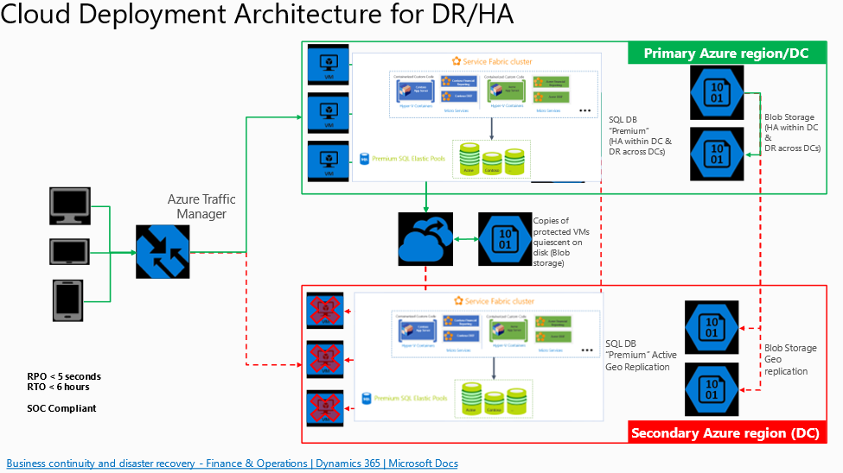

## High Availability

Resource: [High availability - Azure SQL Database and SQL Managed Instance | Microsoft Docs](https://docs.microsoft.com/en-us/azure/azure-sql/database/high-availability-sla?view=azuresql&tabs=azure-powershell)

“The goal of the high availability architecture in Azure SQL Database and SQL Managed Instance is to guarantee that your database is up and running minimum of 99.99% of time without worrying about the impact of maintenance operations and outages. For more information regarding specific SLA for different tiers, refer to [SLA for Azure SQL Database](https://azure.microsoft.com/support/legal/sla/azure-sql-database) and SLA for [Azure SQL Managed Instance](https://azure.microsoft.com/support/legal/sla/azure-sql-sql-managed-instance/).

Azure automatically handles critical servicing tasks, such as patching, backups, Windows and Azure SQL upgrades, and unplanned events such as underlying hardware, software, or network failures. When the underlying database in Azure SQL Database is patched or fails over, the downtime is not noticeable if you [employ retry logic](https://docs.microsoft.com/en-us/azure/azure-sql/database/develop-overview?view=azuresql#resiliency) in your app. SQL Database and SQL Managed Instance can quickly recover even in the most critical circumstances ensuring that your data is always available.”

## Geo-replication

Resource: [Active geo-replication - Azure SQL Database | Microsoft Docs](https://docs.microsoft.com/en-us/azure/azure-sql/database/active-geo-replication-overview?view=azuresql)

“Active geo-replication is a feature that lets you to create a continuously synchronized readable secondary database for a primary database. The readable secondary database may be in the same Azure region as the primary, or, more commonly, in a different region. This kind of readable secondary databases are also known as geo-secondaries, or geo-replicas.

Active geo-replication is designed as a business continuity solution that lets you perform quick disaster recovery of individual databases in case of a regional disaster or a large-scale outage. Once geo-replication is set up, you can initiate a geo-failover to a geo-secondary in a different Azure region. The geo-failover is initiated programmatically by the application or manually by the user.”

Production contains a 28-day point in time restore option.

Database backups of production can be stored in the Asset Library (<14 GB), or locally at CLIENT as needed.

Code can be stored in the DevOps repos, or locally at CLIENT as needed beyond the existing DevOps geo-replication services.

# Tier-2 sandbox recovery

## High Availability

Resource: [High availability - Azure SQL Database and SQL Managed Instance | Microsoft Docs](https://docs.microsoft.com/en-us/azure/azure-sql/database/high-availability-sla?view=azuresql&tabs=azure-powershell)

“The goal of the high availability architecture in Azure SQL Database and SQL Managed Instance is to guarantee that your database is up and running minimum of 99.99% of time without worrying about the impact of maintenance operations and outages. For more information regarding specific SLA for different tiers, refer to [SLA for Azure SQL Database](https://azure.microsoft.com/support/legal/sla/azure-sql-database) and SLA for [Azure SQL Managed Instance](https://azure.microsoft.com/support/legal/sla/azure-sql-sql-managed-instance/).

Azure automatically handles critical servicing tasks, such as patching, backups, Windows and Azure SQL upgrades, and unplanned events such as underlying hardware, software, or network failures. When the underlying database in Azure SQL Database is patched or fails over, the downtime is not noticeable if you [employ retry logic](https://docs.microsoft.com/en-us/azure/azure-sql/database/develop-overview?view=azuresql#resiliency) in your app *[via exception handling try/catch for example]*. SQL Database and SQL Managed Instance can quickly recover even in the most critical circumstances ensuring that your data is always available.”

## Geo-replication

Resource: [Backup retention policy for sandbox environments changed to 14 days - Dynamics 365 Release Plan | Microsoft Docs](https://docs.microsoft.com/en-us/dynamics365-release-plan/2020wave1/finance-operations-crossapp-capabilities/backup-retention-policy-sandbox-environments-changed-14-days)

Data from sandbox is retained for up to 14 days and will soon be for just 7 days. Choosing a date prior to 14 days for a point-in-time restore of Sandbox will be prohibited.

Database backups of Tier-2 can be stored in the Asset Library (<14 GB), or locally at CLIENT as needed.

Code can be stored in the DevOps repos, or locally at CLIENT as needed beyond the existing DevOps geo-replication services.

[To discuss need for cadenced DB backups at CLIENT]

[Code will be maintained in Develop branch]

# Tier-1 disaster recovery/availability

Availability contingent on the resource definitions in CLIENT's Azure portal. Requires re-deployment by CLIENT of the Azure resource and manual restoration of any available database backups from other D365FO systems if system becomes unusable. These VM’s are not backed up by Microsoft.

Database backups of Tier-1 can be stored in the Asset Library, or locally at CLIENT as needed.

Code can be stored in the DevOps repos, or locally at CLIENT as needed beyond the existing DevOps geo-replication services.

[To discuss need for cadenced DB backups at CLIENT]

[Code will be maintained in Develop branch]

[Availability options for Azure Virtual Machines - Azure Virtual Machines | Microsoft Docs](https://docs.microsoft.com/en-us/azure/virtual-machines/availability#use-availability-zones-to-protect-from-datacenter-level-failures)

# Dynamics 365 Project Operations/CE

## Business Continuity and Disaster Recovery

Resource: [Business continuity and disaster recovery for Dynamics 365 SaaS apps - Power Platform | Microsoft Docs](https://docs.microsoft.com/en-us/power-platform/admin/business-continuity-disaster-recovery)

“Microsoft provides disaster recovery for production environments of Dynamics 365 software as a service (SaaS) application for business continuity if there's an Azure region-wide outage.” Details on disaster recovery can be viewed in the first section above.

There’s no local option of CE environments but there is a 7-day point-in-time restore option.

## Sandbox Environments

Resource: [Back up and restore environments - Power Platform | Microsoft Docs](https://docs.microsoft.com/en-us/power-platform/admin/backup-restore-environments)

Protecting the data and providing continuous availability of service are important. There are options for backing up and restoring Sandbox environments using Manual or System backups. Manual restoration can be performed using both System and Manual backups. The process is detailed in the document above.

# Project Operations Gold Disaster Recover Plan

For Project operations working w/ CE/FO dual write must be stopped and then both CE and FO backups can take place to ensure that the point-in-time restores of both CE/FO are in synch in case a restore of gold is needed.

These backups of Gold are functional architect initiated as the functional team determines when the data in Gold is healthy and when it is in a good state for a backup. The technical architects for both CE and FO then stop dual write and conduct the system backups as needed.

# Azure DevOps

Resource: [Data protection overview - Azure DevOps Services | Microsoft Docs](https://docs.microsoft.com/en-us/azure/devops/organizations/security/data-protection?view=azure-devops)

## High Availability

99.9% uptime guarantee.

The [Azure DevOps - Status](https://status.dev.azure.com/) portal can indicate where around the globe service disruptions are taking place

## Geo-replication

DevOps content is backed up in two regions in same geography. This includes transactional storage for point in time restores as well and effectively stores 6 copies of your organizations data.

# Power BI

## Power BI High Availability

Resource: [Power BI high availability, failover, and disaster recovery FAQ - Power BI | Microsoft Docs](https://docs.microsoft.com/en-us/power-bi/enterprise/service-admin-failover)

“Power BI is fully managed software as a service (SaaS). Microsoft designs and operates it to be resilient to infrastructure failures so that users can always access their reports. The service is supported by a [99.9% SLA](https://www.microsoftvolumelicensing.com/DocumentSearch.aspx?Mode=3&DocumentTypeId=37).

Power BI uses **Azure Availability Zones** to protect Power BI reports, applications, and data from datacenter failures, and is automatically applied and used for Power BI. Availability Zones are fault-isolated locations within an Azure region, providing three or more distinct and unique locations within an Azure region that have redundant power, cooling, and networking. Availability Zones allow Power BI customers to run mission-critical applications with higher availability and fault tolerance to datacenter failures. Availability Zones provide customers with the ability to withstand datacenter failures through redundancy and logical isolation of services.

For more information about **Availability Zones**, consult the following article, which goes into detail about [Regions and Availability Zones in Azure](https://docs.microsoft.com/en-us/azure/availability-zones/az-overview).”

Microsoft designs and operates Power BI to be resilient to infrastructure failures so that users can always access their reports by leveraging Azure Availability Zones to protect Power BI reports, applications, and data from datacenter failures and **is automatically applied and used for Power BI by default**. The Power BI reporting service is supported by a [99.9% SLA](https://urldefense.com/v3/__https:/eur01.safelinks.protection.outlook.com/?url=https*3A*2F*2Fwww.microsoftvolumelicensing.com*2FDocumentSearch.aspx*3FMode*3D3*26DocumentTypeId*3D37&data=05*7C01*7CRuthie.McWilliams-Boyd*40ey.com*7Cedfa0a725c544310d54f08da848430df*7C5b973f9977df4bebb27daa0c70b8482c*7C0*7C0*7C637968000527160600*7CUnknown*7CTWFpbGZsb3d8eyJWIjoiMC4wLjAwMDAiLCJQIjoiV2luMzIiLCJBTiI6Ik1haWwiLCJXVCI6Mn0*3D*7C3000*7C*7C*7C&sdata=M6X6quE8HaY0b*2Fs8anfVKF1lP7QuF7pJX6KJezw51bQ*3D&reserved=0__;JSUlJSUlJSUlJSUlJSUlJSUlJSUlJSUlJQ!!LrwELaEne27E!8dVcHu585lbWrzUm6jQ5Vk1KrkWpycnR3VhlXWD24mJXzlA0XlZ3jgh1Fd1lzgd6Cv13VP7YqPgvw4ywiuQ4i0mW36sFEhTykQ$).

The Azure Availability Zones are fault-isolated locations within an Azure Region, providing three or more distinct locations that have redundant power, cooling, and networking.

Due to the above failover items, if there is an outage or issue that cause a primary Power BI cluster to be inaccessible, Power BI automatically cuts over to a backup instance that restores availability and operability in Power BI. In the event of a failure, the back-up instance is available and operational within 15 minutes.

Data sync is also continuously performed by the Power BI service across instances to ensure the back-up instances have up to date data.

The above pertains to the reports themselves, definitions, and any data ingested/stored on the actual reporting layer.

The backup of the actual source data for the reports is handled in the same way **assuming they are stored on Azure services (Azure Data Lake Gen 2, Azure SQL server, Dataverse, etc)** as this is how Microsoft ensures the continuity of the entire Azure platform. It should be noted that once an instance of Power BI or Data Lake is cutover to a back-up instance - it is put into Read-only mode until cutover back to the primary cluster happens to ensure no data loss.

During development using the Power BI application to design reports it is recommended by EY to store the PBIX file and all related files in Microsoft one-drive of DevOps to ensure there isn’t an impact if the development environment where the Power BI reports are being designed fails.

Report definitions can be stored in DevOps or externally on local CLIENT device as needed.